The JK Festival of Orienteering, Easter 2019 - as close to home as it gets!

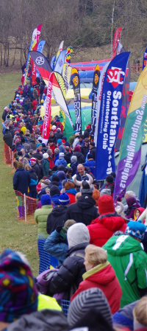
If you have never attended a JK orienteering festival, next Easter the 4 days of orienteering will be as close as it is ever likely to be, so the ideal opportunity to join in and enjoy the experience. JK stands for Jan Kjellstrom, a young man who came over from Sweden in the 1960’s to help get orienteering going and then tragically died in a car crash. This annual event is held in his honour and has grown from 2 to 4 days over the Easter weekend, attracting around 3,000 competitors, including from overseas.
The format is now a Sprint on Friday 19th April (Aldershot Garrison), a Middle distance on Saturday 20th (Old Windmill Hill, Mytchett), a Classic Long distance on Sun 21st (Cold Ash, NE Newbury) and finally a Team Relay on Mon 22nd (Minley, adjacent to Jn 4a of the M3). You can enter any or all of the first 3 individual events; our club captain will be compiling relay teams nearer the time.
It’s hard to convey the atmosphere of a JK. Colour, club banners, club tents, spectator controls and a wide run –in with commentary, top runners from many countries mixing happily with complete novices – there can’t be many sports that can do that all at the same time! This may sound daunting but it’s really great fun and, for those who want it, some very good competition to measure yourself up against. Many seasoned orienteers attend every year and meet up with old friends: there’s a real social buzz about the place.

You will see that entry fees are higher than ‘normal’ – on top of high land access charges, an event on this scale needs extras – marquees, commentary, lots of loos, podium for prize-giving, parking for 2000 cars that needs tracks to be rebuilt and track matting on grassy fields. This is also an event that is expected to raise funds for our sport, so two thirds of any surplus goes to British Orienteering; the rest goes to your region, SCOA, which invests heavily in training and supporting the regional junior squad. Entries will open by the start of December with fees increasing in bands up to 24th March, so apply by 13th January for the lowest entry fee.

The traders that regularly attend the November Classic will be there, along with others. And, like the 50th November Classic, there will be a souvenir orienteering top to buy if you wish.

All this is put on by volunteers with a few contractors providing special services. Each day will need about 130 volunteers, so please consider offering to help, even if you decide not to compete. All volunteers committing to at least 2 hours will get a £5 voucher to be spent at any of the traders; help on all 4 days and have £20 worth of vouchers! Please contact Vicki Barkaway (vickybarkaway@gmail.com) to offer your help and let her know which days you would be available and if you have any preferences of task.

The British Orienteering AGM will be held at Aldershot Garrison on the Friday at about 5pm, so a great opportunity to meet the CEO/Chairman and have your say.

